LAB ASSIGNMENT- 4.4

Name: N.Akash

Enrollment No.: 2503A51L47 Course Code: 24CS002PC215 Course Title: AI Assisted Coding Lab Number: 4.4

BRANCH: CSE

Task 1: Auto-Complete a Python Class for Bank Account

Prompt: Write a class definition comment and start the constructor for a class called BankAccount with account_holder and balance attributes. Use GitHub Copilot to auto- complete the rest of the class, including methods to deposit, withdraw, and display balance.

Python Code:

class BankAccount:

"""A simple Bank Account class with deposit, withdraw, and display balance methods.""" def init (self, account_holder, balance=0):

self.account_holder = account_holder self.balance = balance

def deposit(self, amount):

self.balance += amount

return f"Deposited {amount}. New Balance = {self.balance}"

def withdraw(self, amount):

if amount > self.balance:

return "Insufficient funds" self.balance -= amount

return f"Withdrew {amount}. Remaining Balance = {self.balance}"

def display_balance(self):

return f"Account Holder: {self.account_holder}, Balance: {self.balance}"

Explanation: The class has attributes for account holder and balance. Methods allow deposit, withdrawal with balance check, and displaying account details.

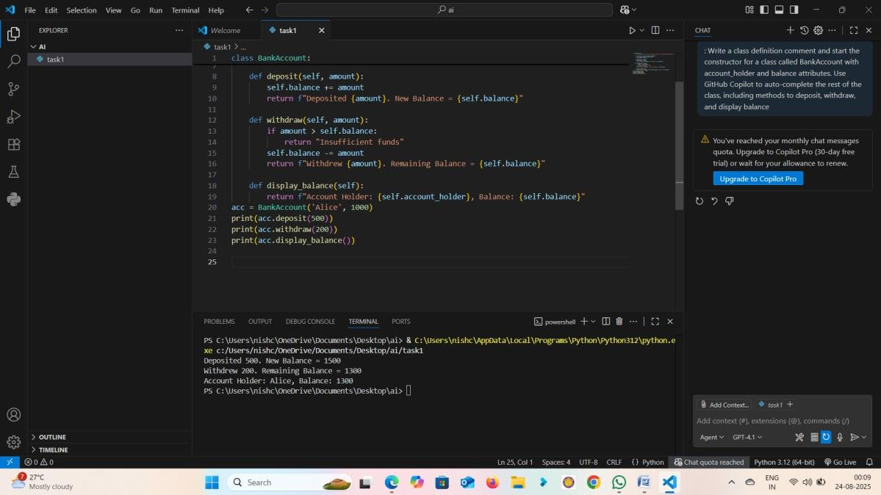

Sample Output:

>>> acc = BankAccount('Alice', 1000)

>>> print(acc.deposit(500)) Deposited 500. New Balance = 1500

>>> print(acc.withdraw(200))

Withdrew 200. Remaining Balance = 1300

>>> print(acc.display_balance()) Account Holder: Alice, Balance: 1300

Observation: The BankAccount class successfully handled deposits, withdrawals, and displayed balance accurately.

Task 2: Auto-Complete a For Loop to Sum Even Numbers in a List

Prompt: Write a comment and the initial line of a loop to iterate over a list. Allow GitHub Copilot to complete the logic to sum all even numbers in the list.

Python Code:

numbers = [1, 2, 3, 4, 5, 6, 7, 8, 9, 10]

even_sum = 0

for num in numbers: if num % 2 == 0:

even_sum += num

print("Sum of even numbers:", even_sum)

Explanation: The loop iterates through the list, checks if each number is even, and adds it to the running sum.

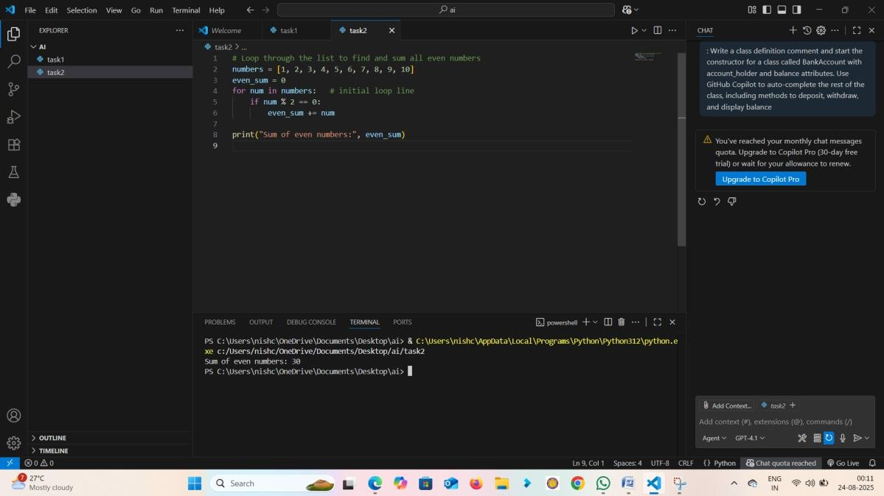

Sample Output:

Sum of even numbers: 30

Observation: The loop correctly iterated and summed even numbers from the list. Task 3: Auto-Complete Conditional Logic to Check Age Group

Prompt: Start a function that takes age as input and returns whether the person is a child, teenager, adult, or senior using if-elif-else.

Python Code:

def age_group(age): if age < 13:

return "Child" elif age < 20:

return "Teenager" elif age < 60:

return "Adult" else:

return "Senior"

Explanation: The function uses if-elif-else conditionals to classify age groups.

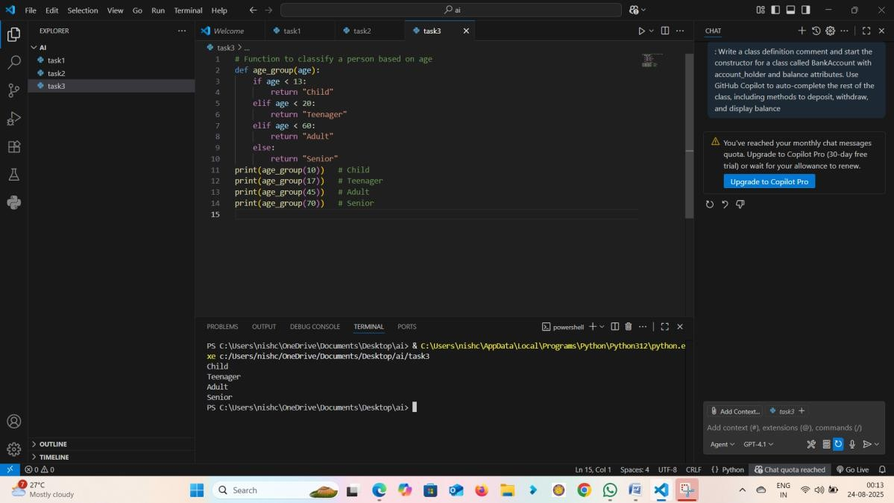

Sample Output:

>>> age_group(10) -> Child

>>> age_group(17) -> Teenager

>>> age_group(45) -> Adult

>>> age_group(70) -> Senior

Observation: The function correctly classified age groups based on input values. Task 4: Auto-Complete a While Loop to Reverse Digits of a Number

Prompt: Write a comment and start a while loop to reverse the digits of a number.

Python Code:

num = 1234

reverse_num = 0 while num > 0:

digit = num % 10

reverse_num = reverse_num * 10 + digit num //= 10

print("Reversed Number:", reverse_num)

Explanation: The loop extracts the last digit using modulo, builds the reversed number, and reduces the original number using integer division.

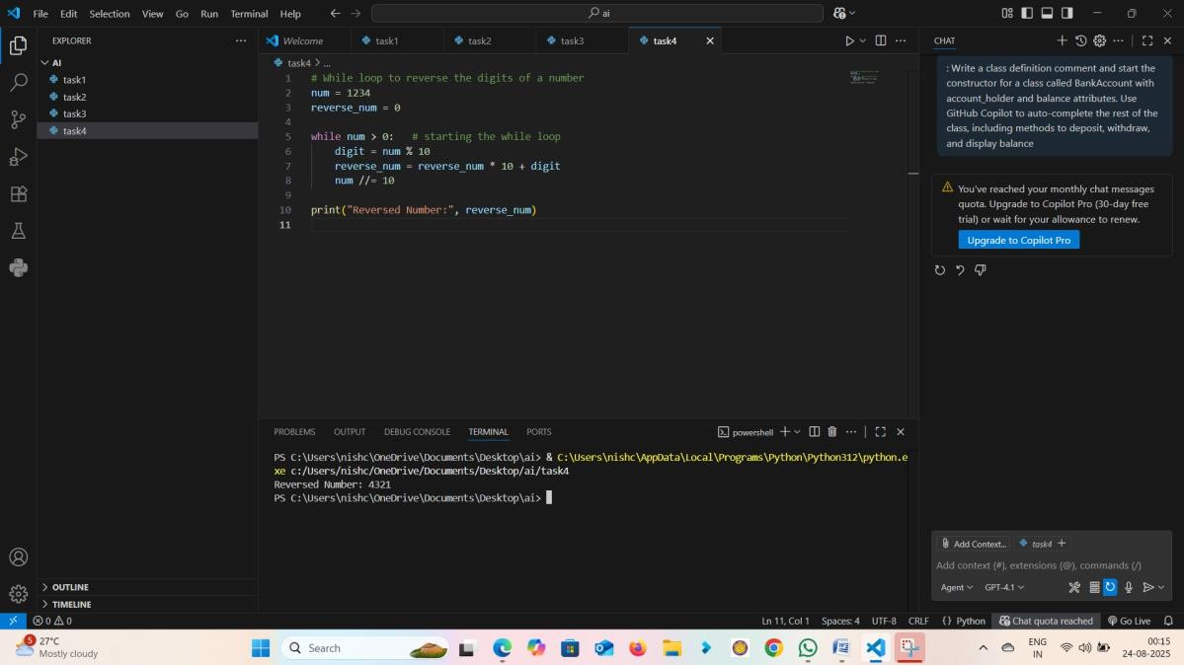

Sample Output:

Reversed Number: 4321

Observation: The while loop reversed the digits of the number without errors. Task 5: Auto-Complete Class with Inheritance (Employee → Manager)

Prompt: Begin a class Employee with attributes name and salary. Then, start a derived class Manager that inherits from Employee and adds a department.

Python Code:

class Employee:

def init (self, name, salary):

self.name = name self.salary = salary

def display(self):

return f"Name: {self.name}, Salary: {self.salary}"

class Manager(Employee):

def init (self, name, salary, department):

super(). init (name, salary) self.department = department

def display(self):

return f"Name: {self.name}, Salary: {self.salary}, Dept: {self.department}"

Explanation: The Manager class inherits from Employee using super() for constructor chaining and overrides the display method.

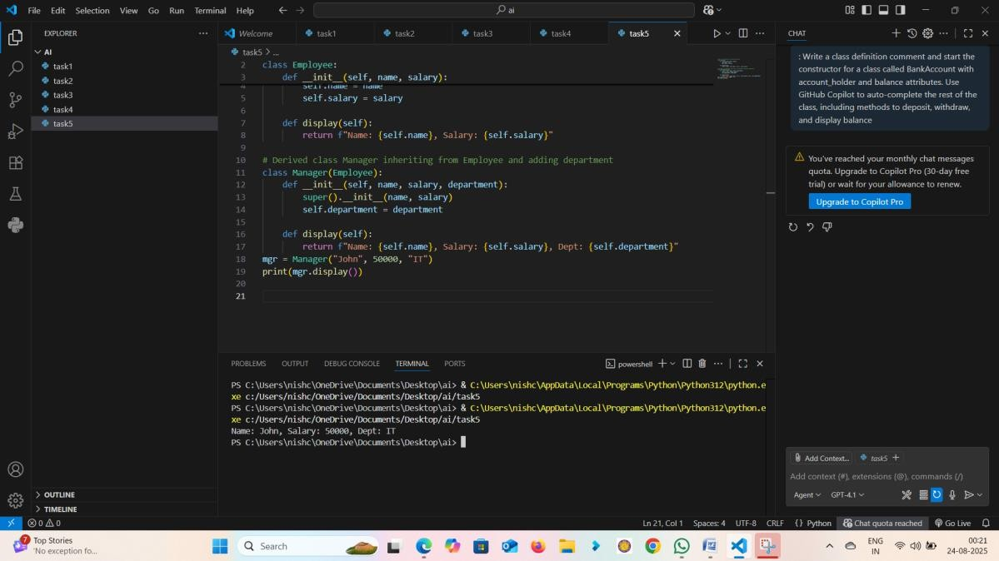

Sample Output:

Name: John, Salary: 50000, Dept: IT

Observation: The Manager class inherited Employee attributes and methods correctly while extending functionality.

Observation

In this lab, we explored GitHub Copilot's ability to auto-complete Python code for classes, loops, and conditionals. We practiced building classes with inheritance, loops for summing and reversing, and conditional logic for classification. This enhanced understanding of AI- assisted coding and Python fundamentals.